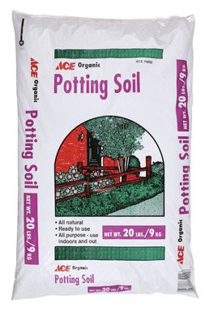
Ace Potting Soil

- 20 lb. Bags
- Indoor/Outdoor Containers
- Ready to use
#13

$3.99
7208705

